User Guide — The Imaginator

The Imaginator — User Guide

Overview
The Imaginator generates high-quality AI images from text descriptions (text-to-image) or from a combination of text and reference images (image-to-image) on a single canvas. It supports a variety of built-in styles, customizable aspect ratios and resolutions, and lets you produce up to 4 variations per generation.
──────────────────────────────────────────────────

Supported input formats
- PNG (.png)
- JPG / JPEG (.jpg, .jpeg)
Maximum file size: 10 MB per reference image
──────────────────────────────────────────────────

Interface layout
The page is divided into 3 panels:
Panel | Purpose
Left (Node Panel) | Drag and drop nodes (Prompt, Image Input, Generate, Output) and control the canvas (Undo/Redo/Reset)
Center (Canvas) | Workspace — connect nodes to build your image-generation pipeline
Right (History) | Shows the history of recently generated images
──────────────────────────────────────────────────

How to use
When you open The Imaginator, the default view shows a canvas with three pre-connected nodes: Prompt → Generate → Output.
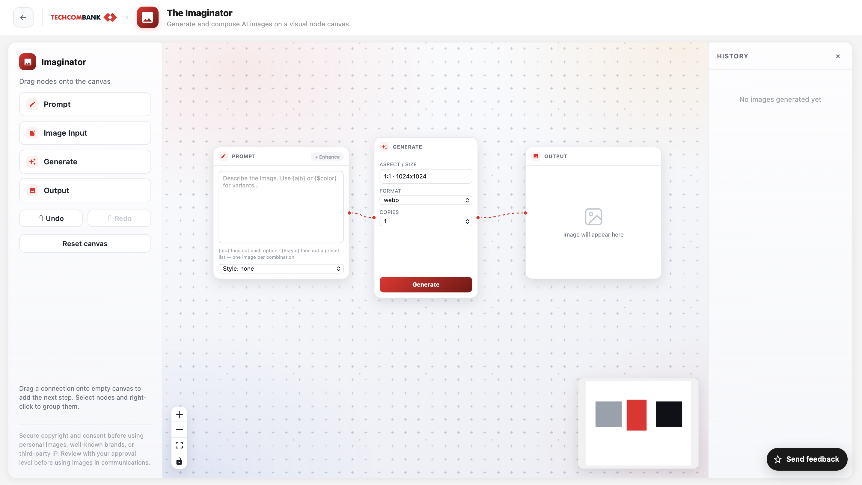

Step 1: Describe the image
In the Prompt node, enter a description of the image you want to create. You can:
- Type the description directly
- Pick a style from the dropdown below the node
- Click “Enhance” to let AI automatically enrich your description
If you want to use an image as a reference, drag the Image Input node from the left panel onto the canvas, upload an image (PNG/JPG, up to 10 MB), then connect it to the Generate node.
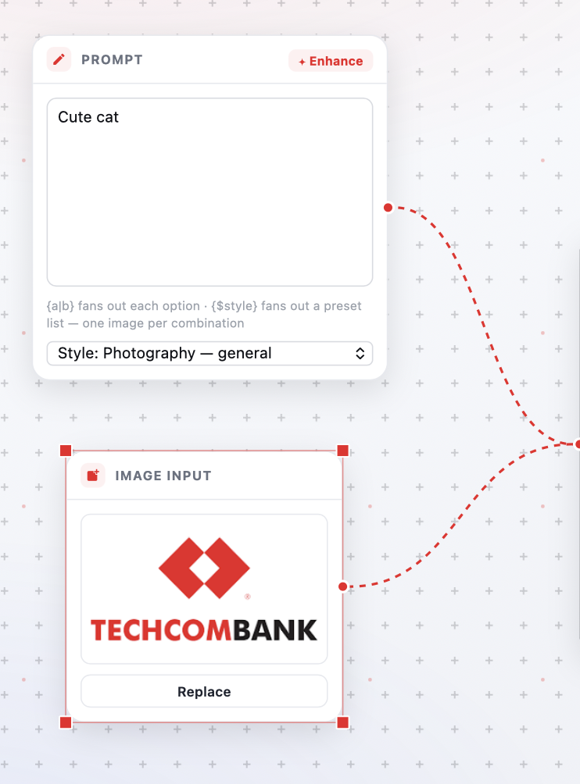

Step 2: Configure generation settings
In the Generate node, configure the following options:
- Aspect ratio / Size — Defaults to 1:1 · 1024×1024; click to change the aspect ratio and resolution
- Format — WebP (default) or PNG
- Number of variations — From 1 to 4
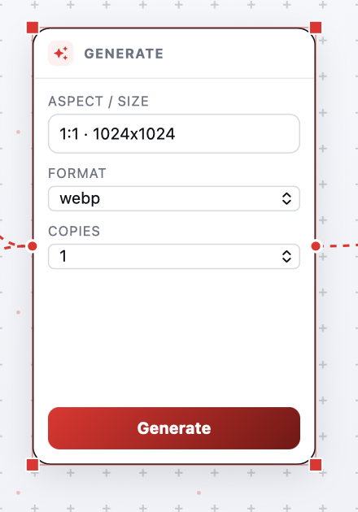

Step 3: Generate the image
Click the red “Generate” button at the bottom of the Generate node and wait for processing.

Step 4: Review and interact with the result
Once complete, the image appears in the Output node with the following actions:
- Text — Add text on top of the image
- Edit — Refine the image with AI
- View — Open the image in full-screen view
- Save — Download the image to your device
- Compare — Compare outputs using a slider
- Input — Use this image as the input for the next generation
- Keep — When you have multiple results, keep the best one
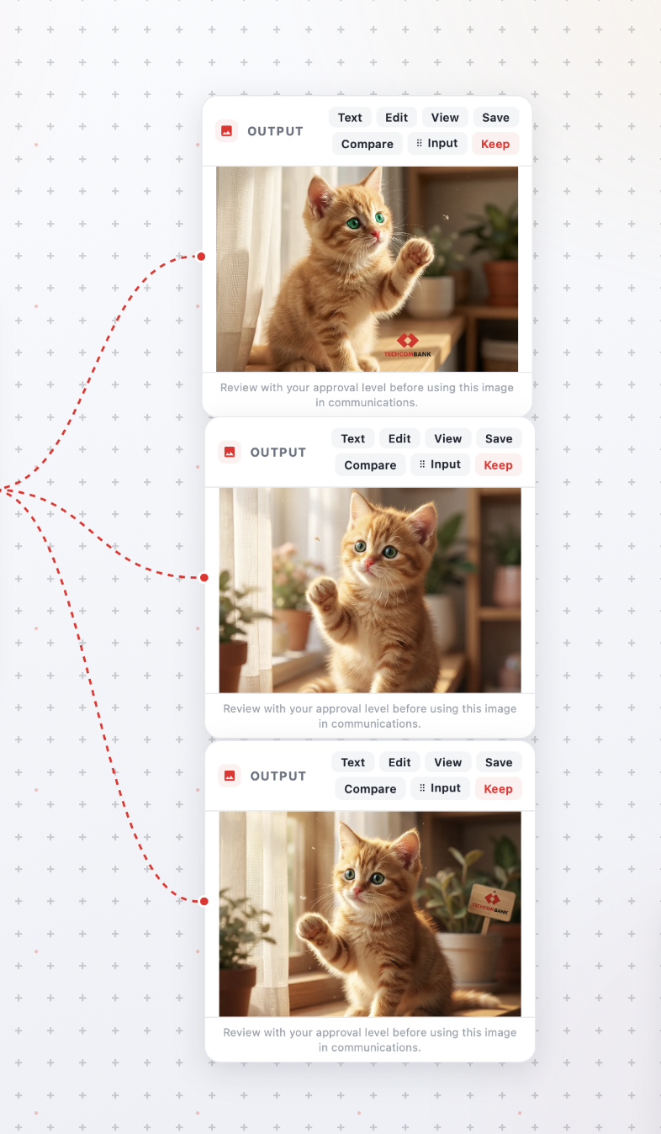
──────────────────────────────────────────────────

Tips
- The more detailed the description, the better — specify the subject, setting, lighting, and camera angle for more accurate results
- Use “Enhance” when your prompt is short or generic — the AI will automatically fill in the details
- Start with the Fast (1K) resolution for experimentation, then switch to Ultra HD (4K) for the final version
- Generate multiple variations (2–4) to have more options, then use Keep to save the best one
- Use the Input button on the Output node to iterate — turn a just-generated image into a reference for the next round
──────────────────────────────────────────────────

Limitations
- Maximum upload size: 10 MB per file
- Input image formats are limited to PNG and JPG
- Maximum variations per generation: 4
- Content that violates safety policies will be blocked automatically
──────────────────────────────────────────────────
Last updated: 10/07/2026

